**In accordance with Snowy Monaro Regional Council’s Purchasing and Tendering Policy Clause 3, Council is seeking written quotations for the following Project.**

|  |  |  |  |  |
| --- | --- | --- | --- | --- |
| **Project Details** | | | | |
| **Project Name** | **Jindabyne Uniting Church – Black Summer Bushfire Recovery** | | | |
| **Project Scope** | SMRC is seeking a Registered Builder to undertake the construction of an extension to the Jindabyne Uniting Church Hall and Kitchen area to increase the capacity and improve safety measures. | | | |
| **Quotation Due** | **4:00 pm Monday 26th September 2022**  Email graham.hope@snowymonaro.nsw.gov.au | | | |
| **SMRC Contact** | As above | | | |
| **Mandatory Site Inspections will be held on site on either**  **Wednesday 14th September or Wednesday 21nd September from 4:00 pm to 5:00 pm.** | | | | |
| **Technical Specification** | | | | |
| **Work Included** | See signed Engineering Plans &  Page 10 of Council approved (DA) plans attached. | | | |
| **Exclusions**  (Work to be undertaken by Council or others) | The following items / services will be provide by Council or others and are not part of the contract for these services:  **N/A** | | | |
| **Deliverables** | **Deliverable** | | **Duration.** | |
| Before commencing works, submit relevant Procedures and SWMS. | | 2 Days | |
| Completed building work | | 6 weeks | |
| As-Built drawings | | 2 weeks after practical completion | |
| **Insurance Requirements** | Public Liability | $20,000,000 | Yes | |
| Professional Indemnity | $5,000,000 | Yes | |
| Workers Compensation | As required by Legislative Requirements | From commencement of the Works | |
| **Qualifications** | Provide confirmation of Registration as a Contractor with NSW Fair Trading | | | |
| **Reference Documents** | 1. Purchasing and Tendering Policy (available from Council’s Website) 2. Health and Safety Policy (available from Council’s website) 3. Smoke Free Work Environment Procedure (available from Council’s website) 4. Work Wear Clothing and Personal Protective Equipment Procedure (available from Council’s website) 5. Alcohol and Other Drug Procedure (available from Council’s website) 6. Code of Conduct (including the model Code of Conduct) (available from Council’s website). | | | |
| **Evaluation Criteria** | **Criteria** | | | **Weighting** |
| Mandatory Criteria Submitted Correctly | | | 10% |
| Demonstrated Capability, Licensing, Experience and Capacity | | | 20% |
| Understanding of the Requirements | | | 10% |
| Relevant Experience | | | 20% |
| Key Personnel | | | 10% |
| Schedule of Prices | | | 30% |
|  | | |  |
|  |  | | |  |

|  |  |  |  |  |
| --- | --- | --- | --- | --- |
| **Project Quotation Form** | | | | |
| **Project Name** | | **Jindabyne Uniting Church – Black Summer Bushfire Recovery** | | |
| **Item No.** | **Description (also refer to work included)** | | **Unit** | **Price Tendered** (Ex GST) |
| 1 | Establishment | | Lump Sum |  |
| 2 | Construction | | Lump Sum |  |
| 3 | Disestablishment | | Lump Sum |  |
| 4 | Other works deemed necessary by Contractor | | Lump Sum |  |
|  | | | **Sub-Total** |  |
| **GST** |  |
| **TOTAL** |  |

|  |  |  |  |  |  |
| --- | --- | --- | --- | --- | --- |
| **Contractors Details** | | | | | |
| Provide the Name and Position of the person making this Declaration who is authorised by the Tenderer to make statements and submit a response on behalf of the Tenderer. | | | | | |
| **Company name** |  | | | | |
| **ABN / ACN** |  | | | | |
| **Representative** | **Name** |  | **Mobile** |  | |
| **Email** |  | | | |
| I confirm my understanding that no physical signature is required on this Declaration and that by lodging this Tender I am automatically providing an electronic signature. | | | | |  |
| I confirm that the Tenderer offers to provide the requirements described in this RFQ at the prices contained in the response. | | | | |  |
| I confirm that the Tenderer has capacity to supply to the requirements described in this document. | | | | |  |
| I confirm that the Tender assessment will be a combination based price weighting and non-price weighting as shown in the “**Evaluation Criteria”**. | | | | |  |

Attachment A

Project Details

1. Scope of Work

The objective of the project is to improve the kitchen facilities at Jindabyne Uniting Church. This kitchen provides meals to the less fortunate in the Jindabyne Community, especially during the winter season. This project is Stage 1 of a number of projects to improve the services provided by the Church.

1. Work Included

* **General Requirements**
  + Before commencing works, submit relevant Procedures and SWMS.
  + Supply of all necessary equipment and resources to undertake the project, including, but not limited to labour, plant, fuel and required materials.
* All workmanship and materials to conform to the latest edition of the Building Code of Australia and relevant Australian standards.
* All work to be completed as per Engineers Drawings and stamped & approved plans. (attached as Combined Plans)

1. Location Diagrams

19 Gippsland Street, Jindabyne Lot: 10 DP: 219583

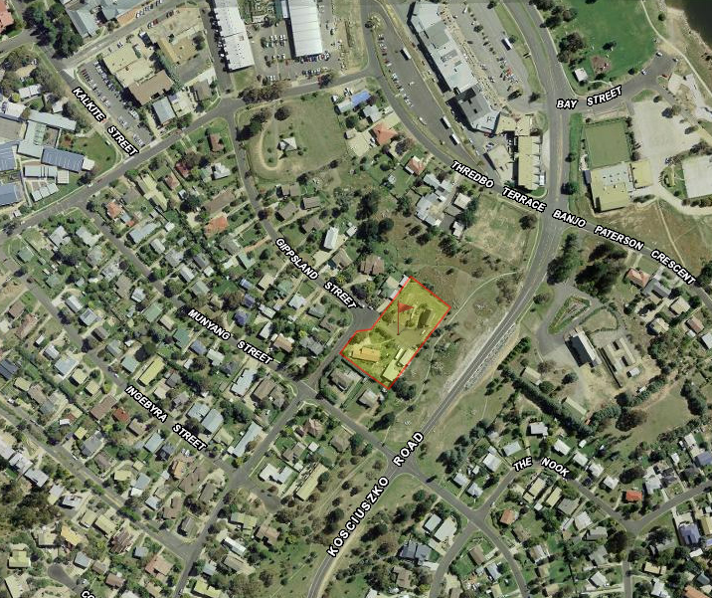

Plan Summary

